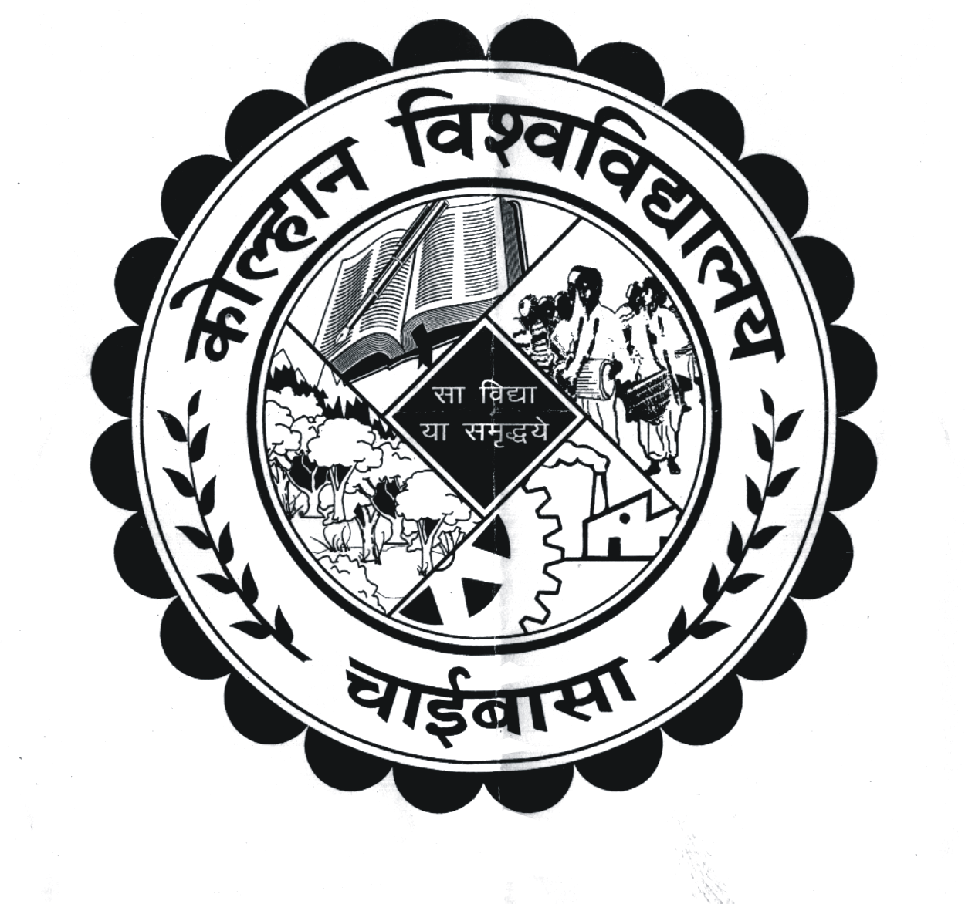
KOLHAN UNIVERSITY, CHAIBASA
(EXAMINATION DEPARTMENT)

The under mentioned candidates are provisionally declared to have passed the P.G. Final Examination, 2018 (Session-2016-18) held in the month of July, 2018

Geology

College/Deptt.: (26A) P.G. Deptt. Kolhan University, Chaibasa

First Class
Pass: Roll No. : 172606524748, 172606524750, 172606524751, 172606524752, 172606524753,

Second Class
172606524747, 172606524749,
By order of the Vice-Chancellor

Sd/- (Dr. P. K. Pani)

Controller of Examinations
Kolhan University, Chaibasa

Memo No. NC/KU/CE/……………………………/18 Dated:…………………………………………
Copy to:
- Head of the Deptt. Concerned, K.U., Chaibasa.
- The Principal of the College concerned.
- Office of the VC /PVC/Registrar for information to VC/PVC/R
- The Editor-(a). Prabhat Khaber, New Jain Market, Chaibasa.
(b). Dainik Jagaran, Chaibasa, (c). Hindustan, Chaibasa
(d). New Ispat Mail, Chaibasa, (e). Dainik Bhaskar
(f). The Hindustan Times, (g). The Telegrapgh
(h). Chamakta Aina, Chaibasa, (i). Uditvani, Chaibasa
(j). Jharkhand News Line, Chaibasa,(k). Farooqui Tanzeeb
(l). I next, Jamshedpur.
for favour of publication in their respective daily, free of cost,
if desired.

Controller of Examinations Kolhan University, Chaibasa

