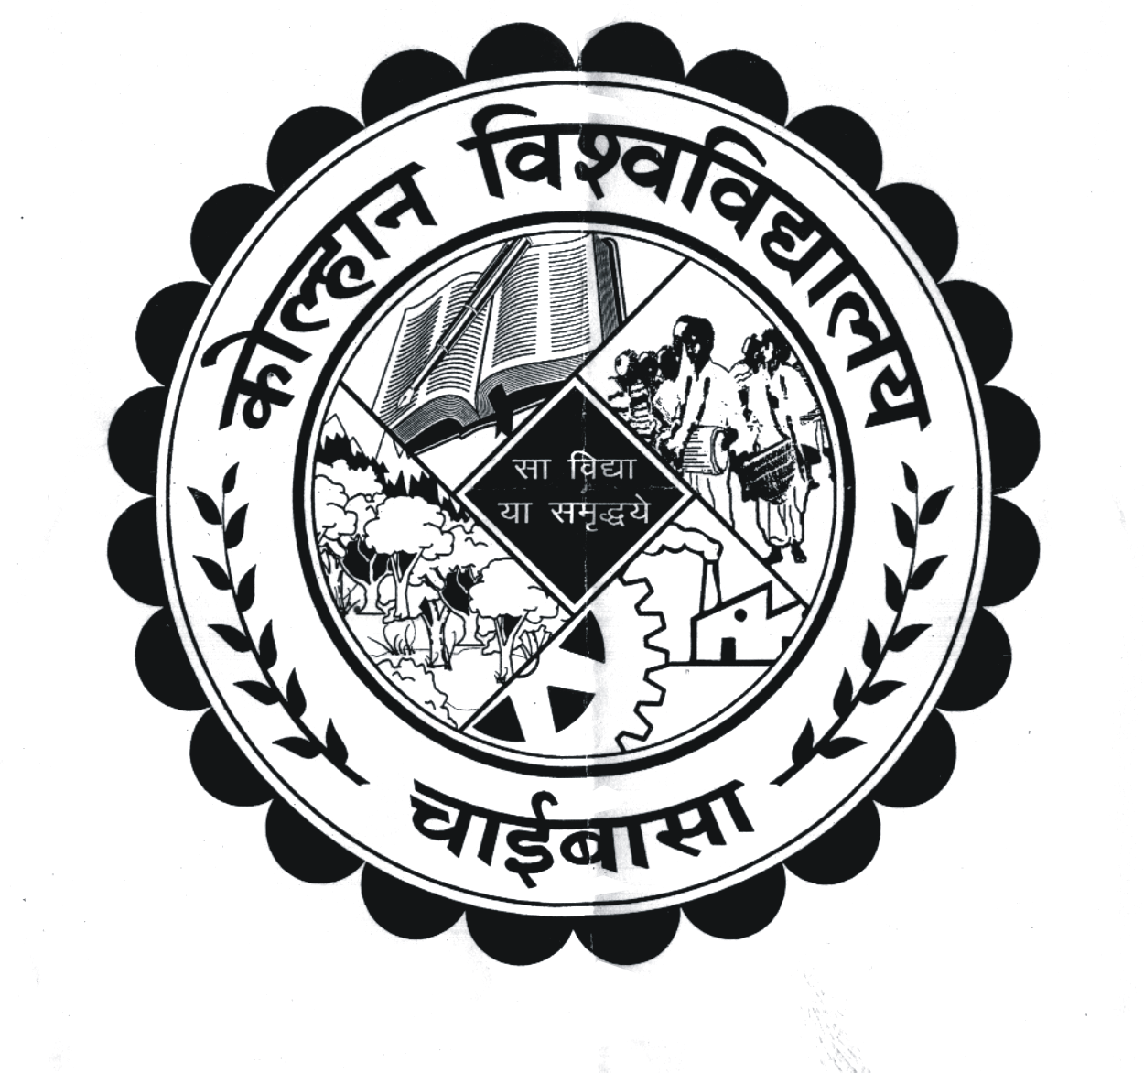
KOLHAN UNIVERSITY, CHAIBASA
(EXAMINATION DEPARTMENT)

The under mentioned candidates are declared to have provisionally passed the 2nd year BDS (Dental) Examination, 2017 (Academic Session 2015-19) held in the month of November, 2017.

College : Awadh Dental College & Hospital, Jamshedpur.
Pass: Roll No. : 162409194213, 218, 223, 227,233, 239, 241, 246, 248, 253, 258, 267, 274, 279, 280, 288, 291, 292

By order of the Vice-Chancellor
Sd/-
(Dr. P.K.Pani)
Controller of Examinations
Kolhan University, Chaibasa

Memo No. NC/KU/CE/ 11343-11345/17 Dated 28/11/2017

Copy to :
1. The Principal of the College concerned.
2. Office of the VC /Registrar for information to VC /R

3. The Editor- (a). Prabhat Khabar, New Jain Market, Chaibasa
(b). Dainik Jagaran, Chaibasa, (c). Hindustan, Chaibasa
(d). New Ispat Mail, Chaibasa, (e). Dainik Bhaskar
(f). The Hindustan Times, (g). The Telegraph
(h). Chamakta Aina, Chaibasa, (i). Uditvani, Chaibasa
(j). Jharkhand News Line, Chaibasa, (k). Farooqui Tanzeeb
(l). Inext, Jamshedpur.
for favour of publication in their respective daily, free of cost, if desired.

Controller of Examinations
Kolhan University, Chaibasa

