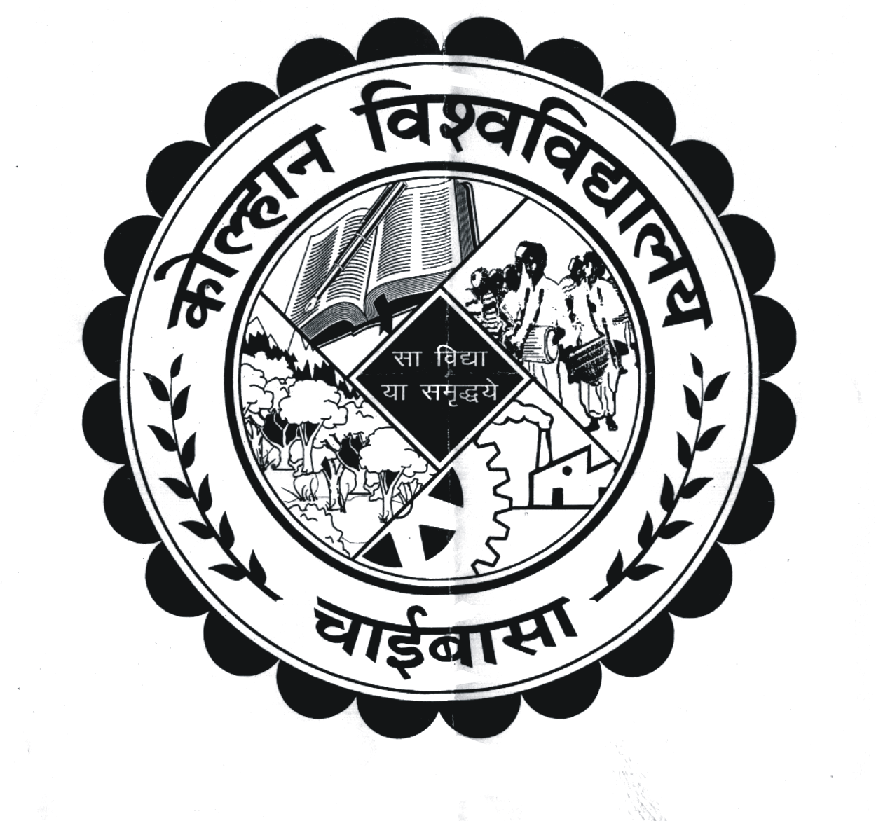
KOLHAN UNIVERSITY, CHAIBASA

(EXAMINATION DEPARTMENT)

Memo No.: NC/KU/CE/13651/18 Dated: 06/01/2018

SCHEME OF EXAMINATION FOR MDS EXAMINATION
(Based on The Dental Council of India, Master of Dental Surgery Course Regulations, 2017) [Effective from the session 2017-20]
ELIGIBILITY:
The following requirements shall be fulfilled by the candidate to become eligible for the final examination.
- Attendance: Every candidate shall secure 80% attendance during each academic year.
- Progress and conduct: Every candidate shall participate in seminars, journal review meetings, symposia, conferences, case presentations, clinic and didactic lectures during each year organised by the concerned department.
- Work diary and log book: Every candidate shall maintain a work diary and log book (as per Annexure-I appended to MDS Course Regulations, 2017 of Dental Council of India) for recording his or her participation in the training programmes conducted by the department. The work diary and log book shall be verified and certified by the Head of the Department of the institution. The certification of satisfactory progress is based on the work diary and log book.
UNIVERSITY EXAMINATION
The university examination shall consist of theory, practical and clinical examination and vivo-voce and Pedagogy
- Theory:
Part –I: Shall consist of one paper
There shall be a theory examination in the Basic Sciences at the end of 1st year of course. The candidates shall have to secure a minimum of 50% in the Basic Science and shall have to pass Part-I examination at least six months prior to the final (Part-II) examination.
Part-II: Shall consist of three papers
- Practical and Clinical Examination;
- Viva-voce; and
- Pedagogy.
A candidate, who wishes to study in a second speciality, shall have to undergo the full course of three years duration in that speciality.
DISSERTATION
Every candidate appearing for the post-graduate degree examination shall at least six months prior to the examinations, submit with his form for examination, four typewritten copies of the dissertation undertaken by the candidate, prepared under the direction and guidance of his/her guide. The dissertation so submitted shall be referred to the examiners for their examination and acceptance of it shall be a condition precedent to allow the candidate to appear for the written part of the examination:
Provided that a candidate whose dissertation has been accepted by the examiner, but declared failed at the examination, shall be permitted to re-appear at the subsequent examination without a new dissertation:
Provided further that if the dissertation is rejected by the examiner, the examiner shall assign reasons therefore with suggestions for its improvement to the candidate and such candidate shall re-submit his/ her dissertation to the examiner who shall accept it before appearing in the examination. If the dissertation is rejected again by the examiner with reasons, the candidate shall not be permitted to appear at the final examination of the University. Such candidate shall re-submit his/her dissertation to the examiner and acceptance of it shall be a condition to allow the candidate to appear for the written part of the supplementary examination/ examination of next year.
CLINICAL/ PRACTICAL EXAMINATION
Clinical/ practical examination is designed to test the clinical skill, performance and competence of the candidate in skills such as communication, clinical examination, medical/ dental procedures or prescription, exercise prescription, latest techniques, evaluation and interpretation of results so as to undertake independent work as a specialist. The Kolhan University shall ensure that the candidate has been given ample opportunity to perform various clinical procedures.
The practical/ clinical examination in all the specialities shall be conducted for six candidates in two days; provided that practical/ clinical examination may be extended for one day, if it is not completed in two days.
VIVA- VOCE EXAMINATION
Viva voce examination aims at assessing the depth of knowledge, logical reasoning, confidence and communication skill of the students.
SCHEME OF UNIVERSITY EXAMINATION
Theory: Part –I: Basic Sciences Paper - 100 Marks
Part-II: Paper-I, Paper-II & Paper-III - 300 Marks (100 Marks for each Paper)
Written examination shall consist of Basic Sciences (Part-I) of three hours duration shall be conducted at the end of First year of MDS course. Part-II Examination shall be conducted at the end of Third year of MDS course. Part-II Examination shall consist of Paper-I, Paper-II and Paper-III, each of three hours duration. Paper-I & Paper-II shall consist of two long answer questions carrying 25 marks each and five questions carrying 10 marks each. Paper-III will be on Essays. In Paper-III three questions will be given and student has to answer any two questions. Each question carries 50 marks. Questions on recent advances may be asked in any or all the papers.
DISTRIBUTION OF MARKS AT THE UNIVERSITY EXAMINATION
Theory : (Total 400 Marks)
- Part I University Examination at the end of First year of MDS course (100 Marks):-
There shall be 10 questions of 10 marks each (Total of 100 Marks)

- Part II University Examination at the end of Third year of MDS course (3 papers of 100 Marks):-
- Paper-I: two long essay questions carrying 25 marks each and five short essay questions carrying 10 marks each. (Total of 100 Marks)
- Paper-II: two long essay questions carrying 25 marks each and five short essay questions carrying 10 marks each. (Total of 100 Marks)
- Paper III: two questions out of three essay questions (50 x 2 = 100 Marks)
Practical and Clinical Examination : 200 Marks
Viva-voce and Pedagogy : 100 Marks
EVALUATION OF ANSWER BOOKS
Part I: There shall be one internal and one external examiner for three students appointed by the Kolhan University for evaluating the answer scripts of the same speciality. However, the number of examiner/s may be increased with the corresponding increase in number of students.
Part II: There shall be four examiners appointed by the Kolhan University in each subject. Out of them, two (50%) shall be external examiners and two (50%) shall be internal examiners. Both external examiners shall be from a university other than the Kolhan University and at least one examiner shall be from a university of different State.
QUALIFICATION AND EXPERIENCE FOR EXAMINERS
The qualification and experience for appointment of an examiner shall be as under:
- An examiner shall possess qualification and experience of a Professor in a post-graduate degree programme;
- A person who is not a regular post-graduate teacher in the subject shall not be appointed as an examiner;
- The internal examiner in a subject shall not accept external examinership in a college for the same academic year;
- No person shall be appointed as an external examiner for the same institution for more than two consecutive years. However, if there is a break of one year, the person can be re-appointed.
EXAMINATION CENTRE
(1) In the event of university examination, one examination centre shall be fixed by the Kolhan University and the students from all the institutions shall take the examination in that centre: Provided that the clinical and viva-voice shall be conducted at their institute.
(2) Rotation of the institutions as centre of examination shall be as per direction of the Kolhan University.
VALUATION OF ANSWER BOOKS
Part-I: Answer book/s shall be evaluated by the internal and external examiner/s and the average marks shall be computed
Part-II: Answer books shall be evaluated by four examiners, two internal and two external and the average marks shall be computed.

CRITERIA FOR DECLARING AS PASS
To pass the university examination, a candidate shall secure in both theory examination and in practical/clinical including viva voce independently with an aggregate of 50% of total marks allotted (50 out of 100 marks in Part I examination and 150 marks out of 300 in Part II examination in theory and 150 out of 300, clinical plus viva voce together). A candidate securing marks below 50% as mentioned above shall be declared to have failed in the examination.
A candidate who is declared successful in the examination shall be granted a Degree of Master of Dental Surgery in the respective speciality.
SYLLABUS DISTRIBUTION IN VARIOUS SPECIALTIES
Prosthodontics and Crown & Bridge
Part I: Paper – I: Applied Basic Sciences: Applied Anatomy, embryology, growth and development Genetics, Immunology, Anthropology, Physiology, Nutrition & Biochemistry, Pathology & Microbiology, virology, Applied Pharmacology, Research Methodology and bio-statistics, Applied Dental anatomy & histology, Oral pathology & Oral Microbiology, Adult geriatric psychology, Applied Dental Materials.
Part II: Paper – I: Removable Prosthodontics and Implant supported Prosthesis (Implantology), Geriatric Dentistry and cranio facial Prosthodontics.
Paper – II: Fixed Prosthodontics, Occlusion, TMJ and esthetic.
Paper – III: Descriptive and analyzing type questions
The topics assigned to the different papers are generally evaluated under those sections. However a strict division of the subject may not be possible and some overlapping of topics is inevitable. Students should be prepared to answer overlapping topics.
Periodontology
Part I: Paper – I: Applied Basic Sciences: Applied Anatomy, Physiology & Biochemistry, Pathology & Microbiology, Pharmacology, Research Methodology and bio-statistics.
Part II: Paper – I: Normal Periodontal structure, Etiology & Pathogenesis of Periodontal diseases, Epidemiology as related to Periodontics.
Paper – II: Periodontal Diagnosis, therapy and Oral implantology.
Paper – III: Descriptive and analyzing type questions
The topics assigned to the different papers are generally evaluated under those sections. However a strict division of the subject may not be possible and some overlapping of topics is inevitable. Students should be prepared to answer overlapping topics.
Oral & Maxillofacial Surgery
Part I: Paper – I: Applied Basic Sciences: Applied Anatomy, Physiology, Biochemistry, Pathology, Microbiology and Pharmacology, Research Methodology and Bio-statistics.
Part II: Paper – I: Minor Oral Surgery and Trauma.
Paper – II: Maxillofacial Surgery.
Paper – III: Descriptive and analyzing type questions
The topics assigned to the different papers are generally evaluated under those sections. However a strict division of the subject may not be possible and some overlapping of topics is inevitable. Students should be prepared to answer overlapping topics.
Conservative and Endodontics
Part I: Paper – I: Applied Basic Sciences: Applied Anatomy, Physiology, Pathology including oral Microbiology, Pharmacology, Bio-statistics and Research Methodology and Applied Dental Materials.
Part II: Paper – I: Conservative Dentistry
Paper – II: Endodontics
Paper – III: Descriptive and analyzing type questions
The topics assigned to the different papers are generally evaluated under those sections. However a strict division of the subject may not be possible and some overlapping of topics is inevitable. Students should be prepared to answer overlapping topics.
Orthodontics & Dentofacial Orthopaedics
Part I: Paper – I: Applied Basic Sciences: Applied Anatomy, Physiology, Dental Materials, Genetics, Pathology, Physical Anthropology, Applied Research Methodology, Bio-statistics and Applied Pharmacology.
Part II: Paper – I: Orthodontic history, Concepts of Occlusion and esthetics, Child and Adult Psychology, Etiology and classification of malocclusion, Dentofacial anomalies, Diagnostic Procedures and treatment Planning in Orthodontics, Practice Management in Orthodontics.
Paper – II: Clinical Orthodontics
Paper – III: Descriptive and analyzing type question
The topics assigned to the different papers are generally evaluated under those sections. However a strict division of the subject may not be possible and some overlapping of topics is inevitable. Students should be prepared to answer overlapping topics.
Oral Pathology & Microbiology and Forensic Odontology
Part I: Paper – I: Applied Basic Sciences: Applied Anatomy, Physiology (General & Oral), Cell Biology, General Histology, Biochemistry, General Pathology, General & Systematic Microbiology, virology, Mycology, Basic Immunology, Oral Biology (Oral & Dental histology), Bio-statistics and Research Methodology.
Part II: Paper – I: Oral pathology, Oral Microbiology & Immunology and Forensic Odontology.
Paper – II: Laboratory Techniques and Diagnosis and Oncology
Paper – III: Descriptive and analyzing type questions
The topics assigned to the different papers are generally evaluated under those sections. However a strict division of the subject may not be possible and some overlapping of topics is inevitable. Students should be prepared to answer overlapping topics.
Pedodontics & Preventive Dentistry
Part I: Paper – I: Applied Basic Sciences: Applied Anatomy, Physiology, Pathology, Microbiology, Nutrition & Dietics, Growth & Development of Dental Plaque, Genetics.
Part II: Paper – I: Clinical Pedodontics
Paper – II: Preventive and community dentistry as applied to Pediatric Dentistry
Paper – III: Descriptive and analyzing type questions
The topics assigned to the different papers are generally evaluated under those sections. However a strict division of the subject may not be possible and some overlapping of topics is inevitable. Students should be prepared to answer overlapping topics.
The Scheme of Examination is effective from the Session 2017-20.

(Dr. P.K.Pani)
Controller of Examinations
Kolhan University, Chaibasa

