Ref No............................. Date : ........................

TO WHOMSOEVER IT MAY CONCERN

Certified that following number of courses offered were having focused on employability/entrepreneurship/ skill development in Master’s and Doctoral Degree program in the University Department of Philosophy during different academic sessions.

Sl. No. | Academic Session | No. of Courses | Web links
1. | 2016-17 | 06 | https://kolhanuniversity.ac.in/index.php/downloads/category/13-syllabus.html
2. | 2017-18 | 06 | https://kolhanuniversity.ac.in/index.php/downloads/category/13-syllabus.html
3. | 2018-19 | 06 | https://kolhanuniversity.ac.in/index.php/downloads/category/13-syllabus.html
4. | 2019-20 | 06 | https://kolhanuniversity.ac.in/index.php/downloads/category/13-syllabus.html
5. | 2020-21 | 18 | https://kolhanuniversity.ac.in/index.php/downloads/category/13-syllabus.html

Dr. Deepanjay Srivastava
Head, University Department of Philosophy,
Kolhan University, Chaibasa

1.1.3.1 Number of Courses having focus on Employability/Entrepreneurship/Skill Development

Programme Objectives (POs)
The University Department of Philosophy was established in 2011. As a centre for postgraduate studies and research, the Department has been serving the students of Jharkhand and even outside Jharkhand, aspiring for Postgraduate studies and Research in Philosophy. The Department offers CBCS based two years postgraduate course which is constituted of four semesters. The Department offers core and elective papers in the postgraduate program. As a centre for philosophical studies and research the Department gives an equal importance to Indian and Western Philosophy, covering Classical, Ancient, Modern and contemporary trends in Philosophy. The Department also encourages scholars to work on Tribal culture, knowledge systems and philosophy.

Aims & Objective:

The Department is committed for the formation of students with regard to character building, enhancement of intellectual abilities, empowering and imparting knowledge with cultural, socio-political, economical and ethical values, development of skillful abilities, competitive professional skills, and for the growth of the dimensions of human consciousness, so that they can lead a better life and build a better society and nation.

Programme Specific outcomes (PSOs)
In the last five years, 240 students pursued Postgraduate degree and 03 Research Scholars completed their Doctoral degree in Philosophy from the Department of Philosophy. At the same time at present 51 postgraduate students are enrolled for pursuing Postgraduate degree and 07 Research Scholars are enrolled for pursuing Doctoral degree. The pass out students are almost getting settled in their life and availing their service to society in different areas. Among them many are occupying the posts both in governmental and private sectors as teacher, police, journalist, businessman etc.

Program specific outcome for each specialization

Postgraduate in Philosophy: Study of Philosophy helps students to think rationally and critically to understand life, world and reality better. In its methodological significance philosophy enables students to grow in different aspects of life. Metaphysics helps students to study about the truth of world and reality beyond physics so as to know the Ultimate reality. Epistemology helps student to learn about the problems of knowledge. Ethics helps students in realizations of human values and logic helps students to grow in their reasoning and thinking abilities.

Doctoral Degree: Doctoral Degree program has attracted students of different field and interest for undergoing research on burning philosophical, cultural and ethical problems. It’s a blessing for researchers who are aspirant for higher education.

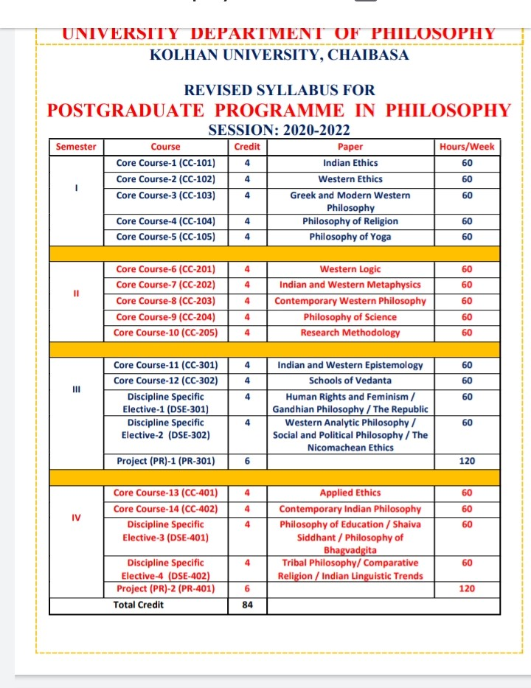

MA Semester I
Core Course: 1 (CC-101) Indian Ethics
The study of Indian Ethics aims at creating awareness regarding Ethical values and its degradation and deterioration at present time. Study of Indian Ethics helps students to grow in Personal Skills applicable for life, industries and Entrepreneurship.

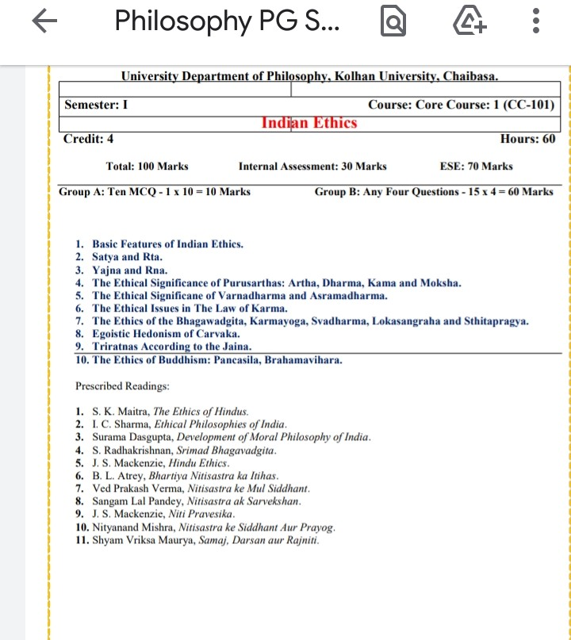

Core Course: 2 (CC-102) Western Ethics
The study of Western Ethics aims at imparting the importance of Ethical values on students and creating awareness regarding its degradation and deterioration at present time in the world. It helps students to grow in awareness on moral Values, skill Development for practical life.
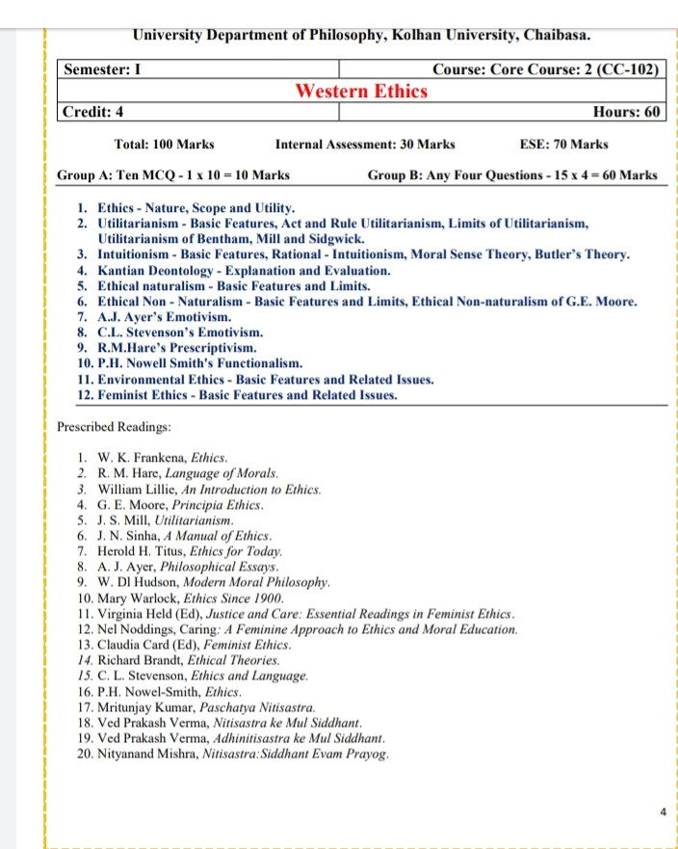

MA Semester IV

Core Course: 13 (CC-401) Applied Ethics
The study of Western applied Ethics aims at the study of ethical problems in present practical and professional lives.
Applicable on Industries

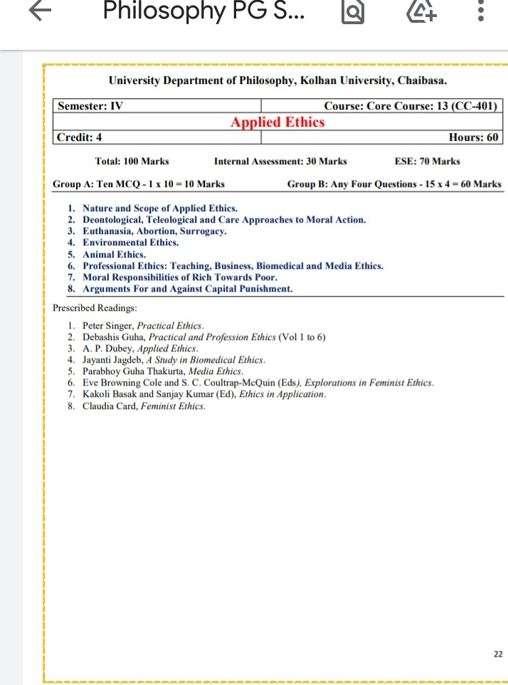
Discipline Specific Elective 2 (DSE-302) The Nicomachean Ethics
The study of Nicomachean Ethics aims at imparting the importance of Ethical values. It gives students to get acquainted with the Nicomachean ethical theory. Study of ethics leads to Skill Development and imparting Moral values.

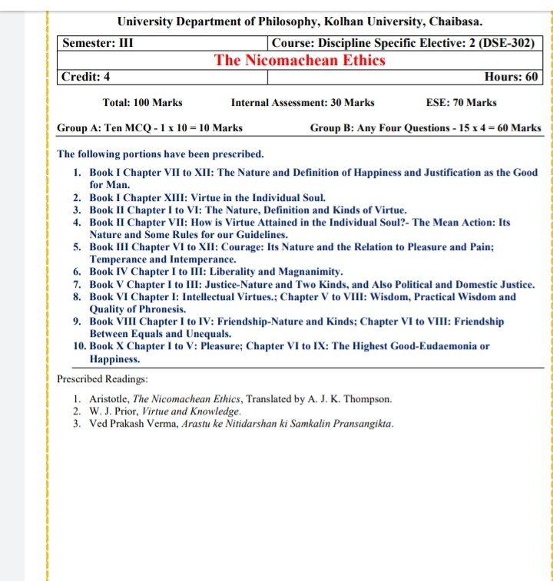

Course Project Report: 1 (PR-301)
Project report helps to assess student’s progress of their creative and critical thinking.Industries and institutions can employ Students on the basis of work experience through Project work.

Course Project Report: 2 (PR-401)
Project work helps to assess the progress of students with regard to creative writings and research abilities.Industries and institutions can employ students on the basis of work experience through Project work

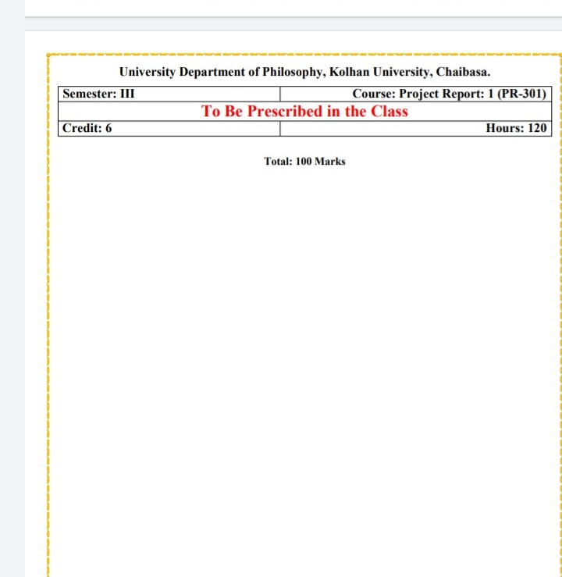

Discipline Specific Elective 3 (DSE-401) Philosophy of Education
The Study of Philosophy of Education leads students to cultivate a better awareness regarding education by studying the views of different thinkers. Study of Philosophy of Education leads students to teachership in schools and colleges.

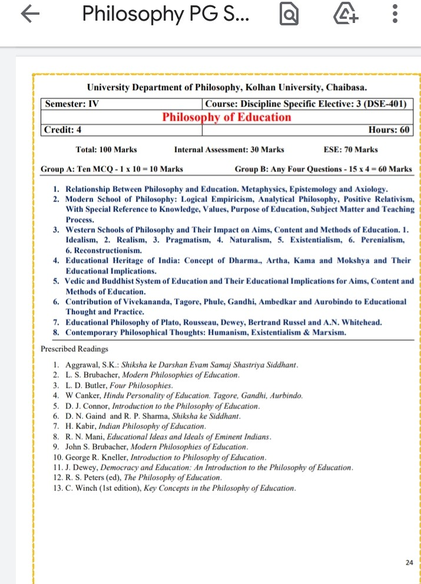

MA Semester III
Discipline Specific Elective 1 (DSE-301) Human Rights and Feminism
The Study of Human Rights and Feminism creates awareness about social justice and equality so as to abolish gender discrimination. This helps students to realize and accept self. It is Leading to Skill Development and Entrepreneurship.

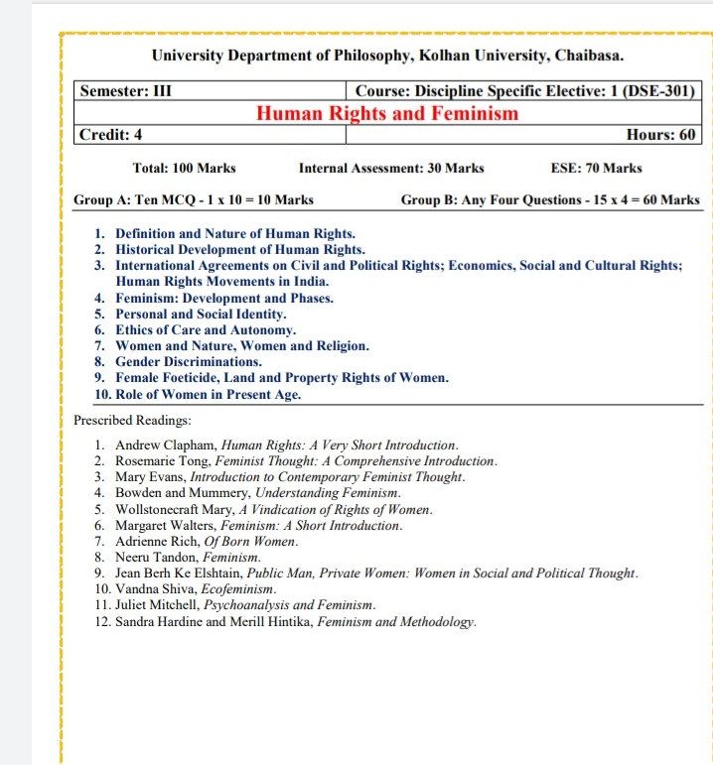

MA Semester II
Core Course: 6 (CC-201) Western Logic
The Study of logic helps students to grow in their reasoning and thinking abilities. The study of logic helps students in the development of mind for thinking logically and critically. It helps in Skill Development, enhancement on reasoning correctly and validly.

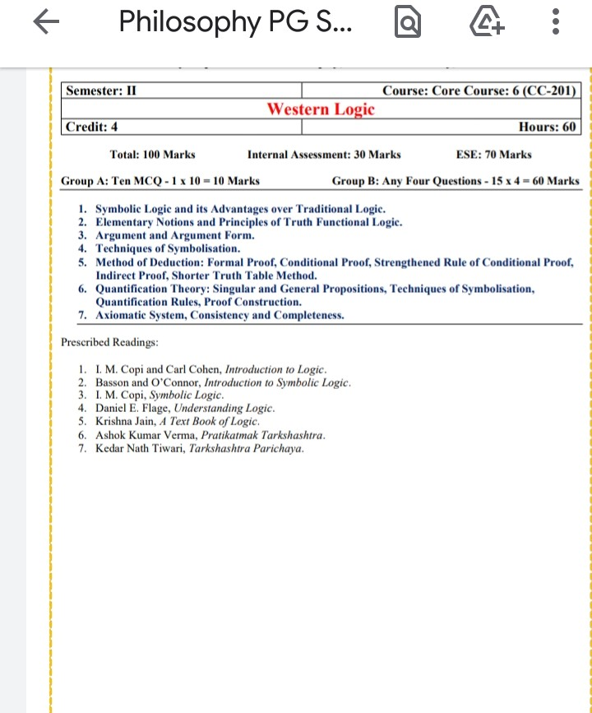

Core Course: 5 (CC-105) Philosophy of Yoga
The Study of Philosophy of Yoga leads students to a disciplined life and helps to have a healthy mind and body. Presently when the world is facing the crisis of Covid-19 the importance and significance of Yoga Philosophy has increased. This is the most secular discipline appealing for physical as well as mental health. Studying Yoga students can go ahead in their professional life as Yoga Teacher in schools, and institutions.

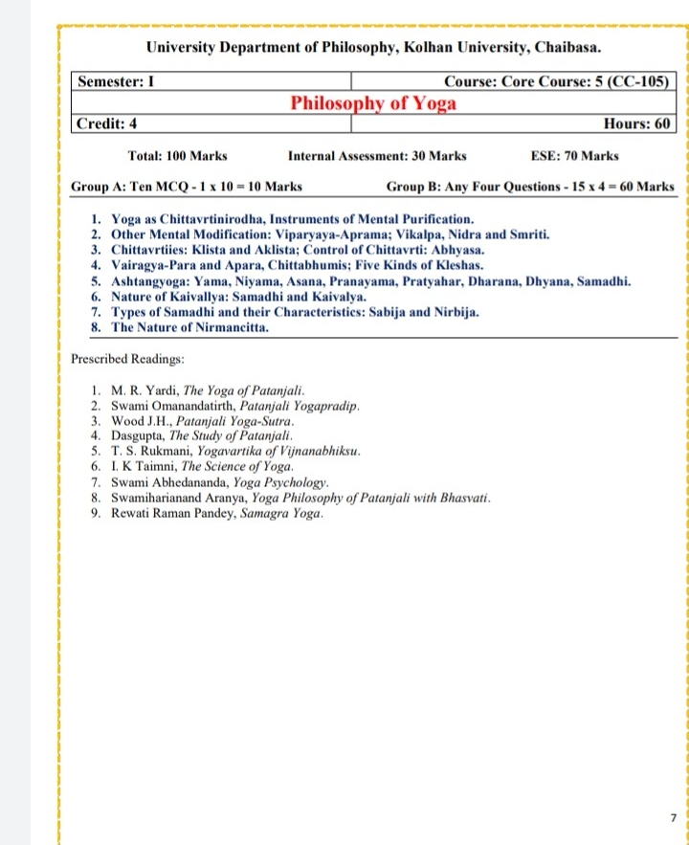
Discipline Specific Elective 4 (DSE-402) Indian Linguistic Trends
The Study of Indian Linguistic Trends helps student to get familiar with the Linguistic philosophy in Indian linguistic traditions.
Skill Development, and Personality Development leading to entrepreneurship, self employability

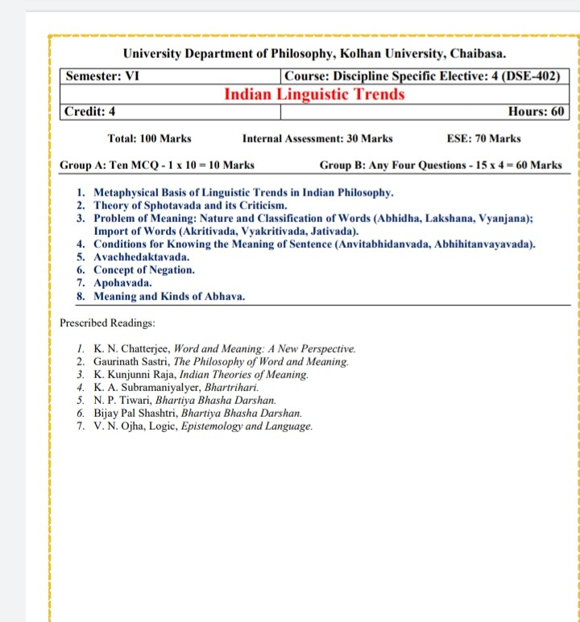

Discipline Specific Elective 4 (DSE-402) Comparative Religion

The study of Comparative Religion helps students to study the living religions of the world comparatively.
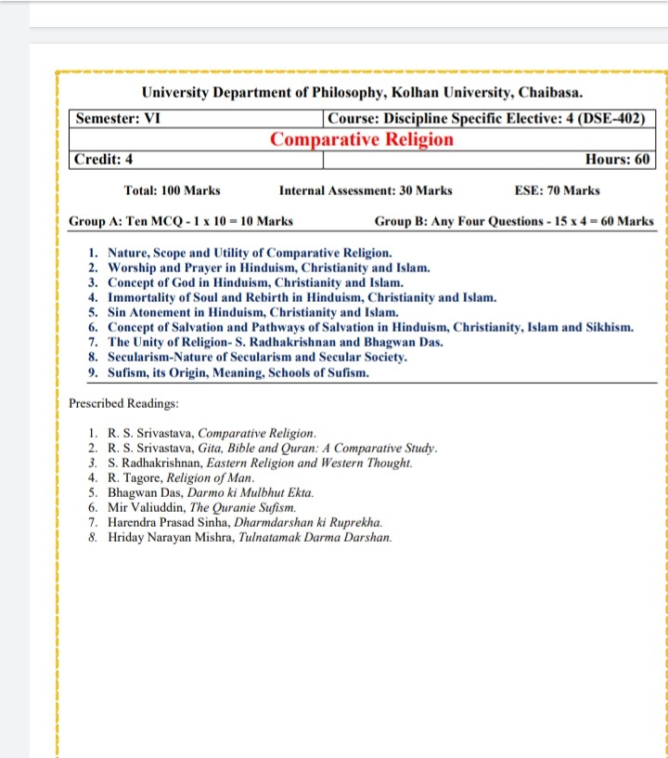

Discipline Specific Elective 3 (DSE-401) Philosophy of Bhagvadgita

The Study of Philosophy of Bhagvadgita leads to a specific and a deep study of Philosophy of Bhagvadgita.
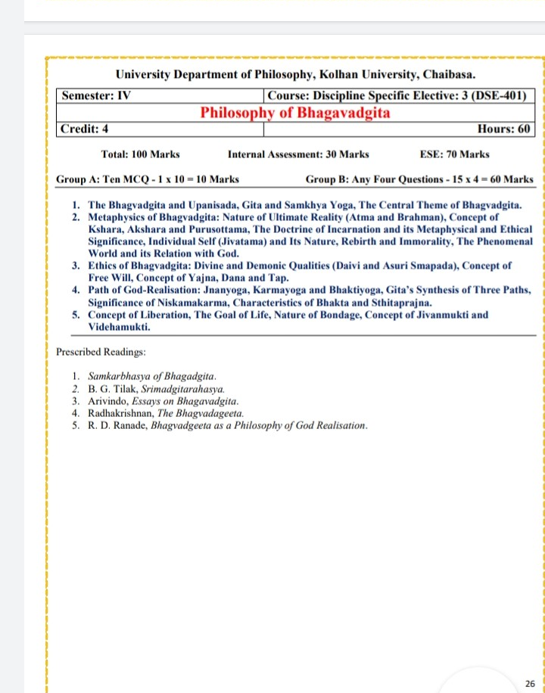

Discipline Specific Elective 2 (DSE-302) Social and Political Philosophy
The Study social and political philosophy creates awareness about socio-political problems with philosophical approaches which leads to an awareness for justice, peace and harmony in society and nation. It helps students to grow in the area of Entrepreneurship and Skill development.
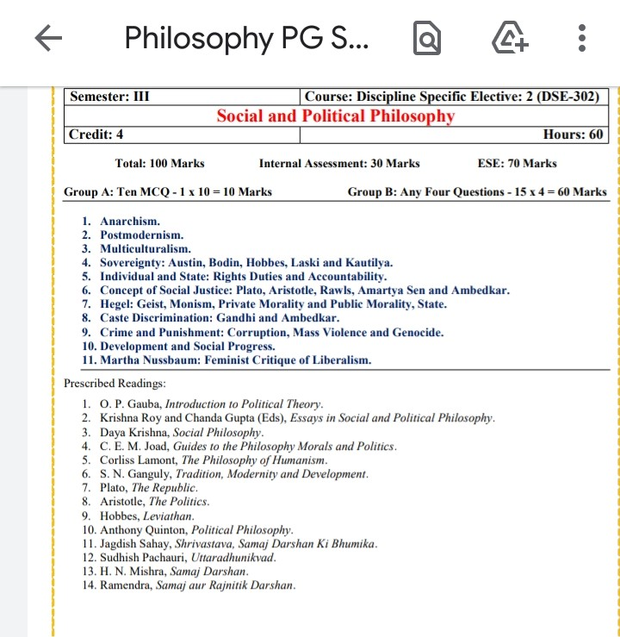

Core Course: 4 (CC-104) Philosophy of Religion
The Study of Philosophy of religion helps students to study religion with philosophical approaches. It helps students to learn different aspects of religious valuesthat are imbibed in faith traditions. Students can go ahead further in their life with this certification in the institutions wherever there are posts related to religious institutions.
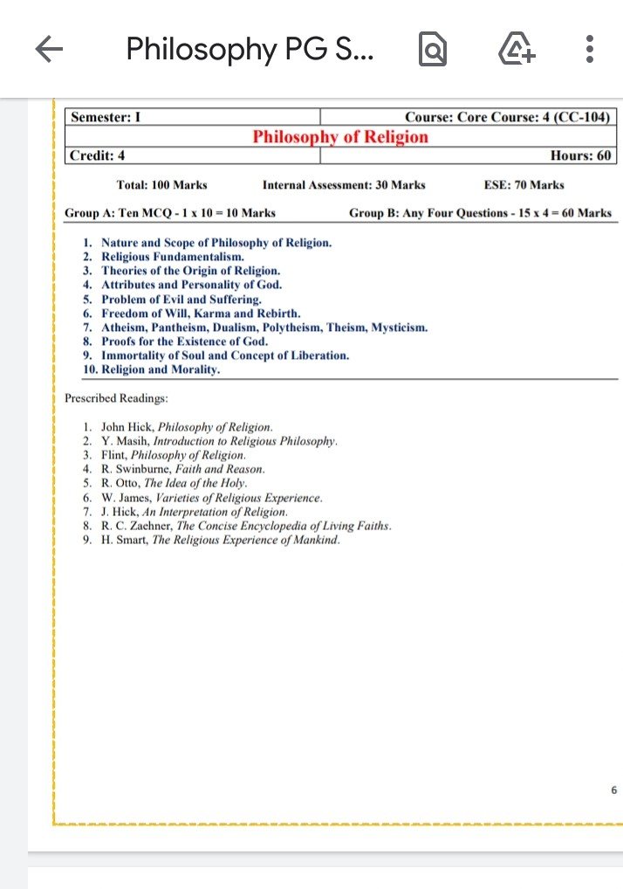

Discipline Specific Elective 1 (DSE-301) Gandhian Philosophy
The study of Gandhian Philosophy has an aim an objective for the promotion of Gandhian thought. It brings an awareness regarding Gandhian thought, its relevance and need for present socio-political scenario of the nation. It leads to Self employability and Entrepreneurship.

