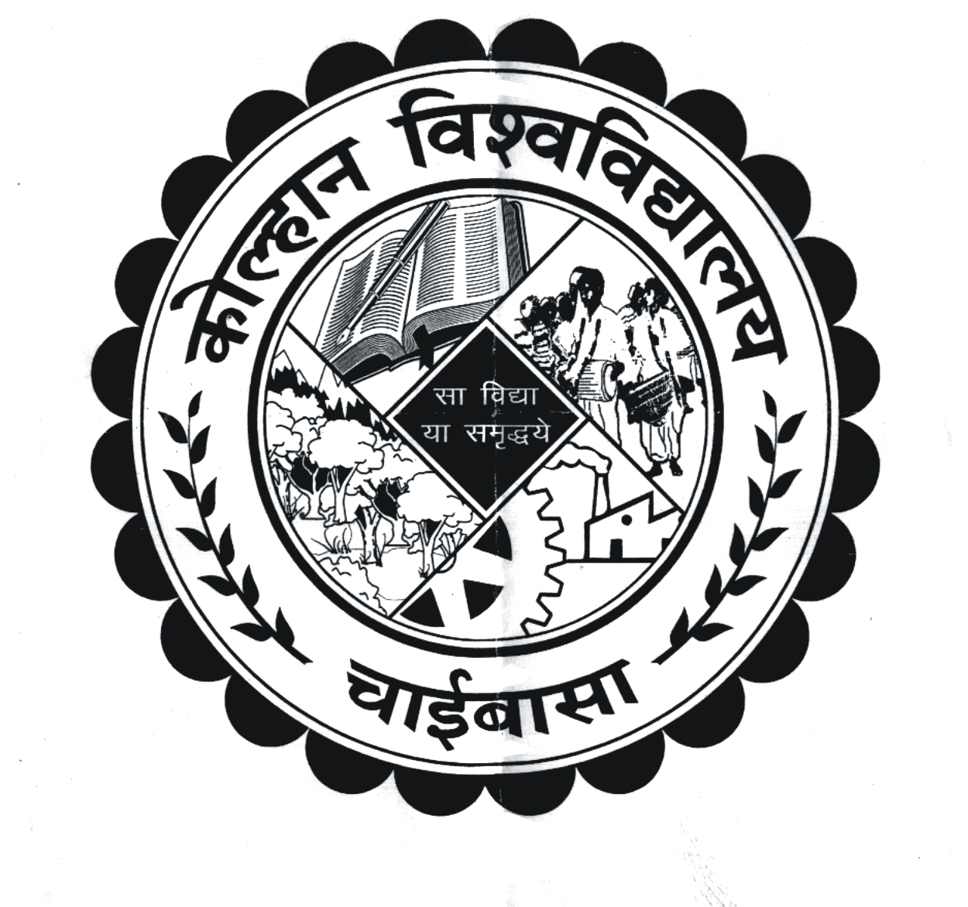
KOLHAN UNIVERSITY, CHAIBASA
(EXAMINATION DEPARTMENT)

NOTIFICATION

This is to notify for information of all concerned that the date of filling up of examinations form & fee of under mentioned courses will be as follows :-

Name of Examination | Date of filling up exam. form by the students in the college/Inst. without fine. | Date of Submission of exam. form by the college/Inst. in University office without fine.
BCA & BBA 1st Semester Exam. – 2017  (Session : 2017 – 2020) | 05/01/2018  to  13/01/2018 | 17/01/2018

N.B. :- (i) No Individual form &fee will be accepted in the university office from the candidate.
(ii) Photocopy of admit card & mark sheet of last exam should be enclosed with each
Examination form.
(iii) Principal of the concerned affiliated college has to be submit an undertaking mentioning “if any fault will be detected in future regarding bonafied candidature of the student/affiliation of the course then college authority will be responsible for the same.”
(iv) Examination fee will be Rs. 800/- per examinee.
(v) Cost of Exam form: - Rs. 50/-
(vi) 02 Check list will be submitted by the college along with soft copy (C.D). The format is given below.

Sl. No. | Student Name | Father Name | Date of Birth | Reg. No. | Previous Roll NO./IDR No. | Subject

By order of the Vice-Chancellor
Sd/-
( Dr.P.K. Pani )
Controller of Examinations
Kolhan University, Chaibasa

Memo No. NC/KU/CE/13588-13591/17 Date: 21/12/2017

Copy to :
- Principals of all Colleges under Kolhan University, Chaibasa
- F.O., Kolhan University for information & needful.
- P.A. to VC/PVC/R for information of VC/PVC/R

The Editor- (a). Prabhat Khaber, New Jain Market, Chaibasa
(b). Dainik Jagaran, Chaibasa, (c). Hindustan, Chaibasa
(d). New Ispat Mail, Chaibasa, (e). Dainik Bhaskar
(f). The Hindustan Times (g). The Telegraph
(h). Chamakta Aina, Chaibasa (i). Uditvani, Chaibasa
(j). Jharkhand News Line, Chaibasa, (k). Farooqui Tanzeeb
for favour of publication in their respective daily, free of cost, if desired.

Controller of Examinations
Kolhan University, Chaibasa

